Want a career that really makes a difference?
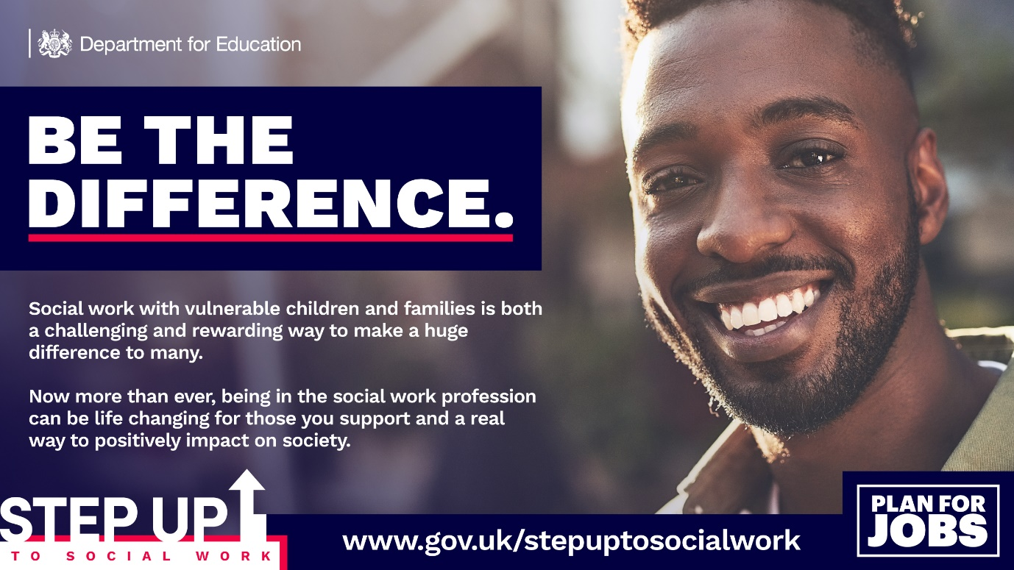
Step Up to Social Work is a Department for Education (DfE) initiative which aims to increase the number of high quality social workers by supporting graduates and career changers to start a new career in social work, working with vulnerable children, young people and families.
- Step Up to Social Work is a full-time, fully funded Programme, providing a recognised social work qualification
- It’s 14-months of intensive study and work based placements
- Leading to a Postgraduate Diploma in Social Work
The programme is delivered locally by the University of East London in partnership with local authorities across North East London including the London Borough of Havering.
- Applications for places open on the Department for Education website on 15th February 2021 and close on 7th April 2021.
- The programme will commence in January 2022, finishing in March 2023.
You are eligible to apply for the programme if you have:
- An honours degree (1st or 2.1) OR
- A 2.2 honours degree with an additional post graduate qualification at level 6, such as a postgraduate diploma or masters degree AND
- GCSE Maths and English at grades C or above (or equivalent) AND
- Experience of working with children and families

For more information and to apply please click on the following link to the DfE website - https://www.gov.uk/guidance/step-up-to-social-work-information-for-applicants

You can also book a place on one of the North East London online information sessions, delivered by Programme Coordinators from across North East London and UEL.

The sessions will provide information on the academic programme, selection process, funding arrangements, and more.

To book a place at one of the events please use the links below:

https://www.eventbrite.co.uk/e/step-up-to-social-work-202123-information-event-tickets-141261166953

Session One: Tuesday 02 March 17.30 – 19.00 via Zoom
Session Two: Wednesday 10 March 17.30 – 19.00 via Zoom
Session Three: Saturday 20 March 10.30 – 12.00 via Zoom
Session: Four: Monday 22 March 11.00 – 12.30 via Zoom

